Que-19: How Do You Handle Exceptions With Try/Except/Finally In Python? Explain with coding snippets.

ANS-----> Try : This block will test the excepted error to occur

Except : Here you can handle the error

Finally : Finally block always gets executed either exception is generated or not

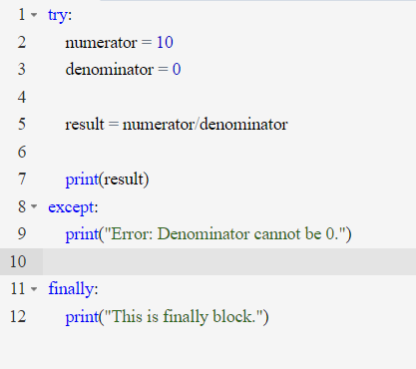

Output : -

